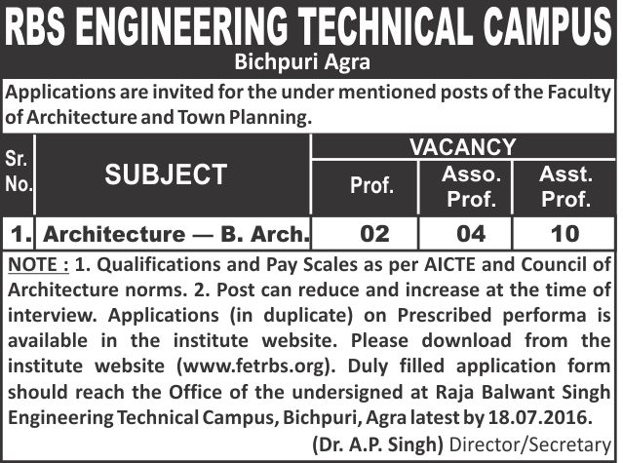

Form No………………………..
RAJA BALWANT SINGH ENGINEERING TECHNICAL CAMPUS
BICHPURI, AGRA

FACULTY OF ARCHITECTURE & TOWN PLANNING
Application for the post of _________________________________________________
- Name_________________________________________________________

PHOTO
- Father’s / Husband’s Name_______________________________________
- Date of Birth___________________________________________________
- Religion____________________________Caste______________________
- Permanent Address_____________________________________________
_________________________________________________________________________________
- Telephone / Mobile Number :________________________________________________________
- E-mail______________________________________________________________________________
- Name of two referees (1)__________________________________________________________
(2)___________________________________________________________
- Academic Qualification:
Examination Passed | Years | Division | Percentage of Marks | Subject Offered | Name of University and the Institutions
1. High School
2. Intermediate
3. Degree
4. Post Graduate
5. ____________
6. ____________
7. ____________
8. ____________

- Teaching Experience :

- Degree _______________________Years
- Post graduate__________________Years

- Professional Experience:
Name of Employer | Date of Joining | Date of Leaving | Nature of job | Salary | Reason for leaving

- Brief Statement about research and publications (if any):

- Any additional remarks:

Signature____________________
Date_________________________

Note :
Self Attested copies of the mark sheets, certificates and testimonials of all the examinations and experience certificates should be attached with the application.

DUPLICATE COPY
Form No………………………..
RAJA BALWANT SINGH ENGINEERING TECHNICAL CAMPUS
BICHPURI, AGRA

FACULTY OF ARCHITECTURE & TOWN PLANNING
Application for the post of _________________________________________________
- Name_________________________________________________________

PHOTO
- Father’s / Husband’s Name_______________________________________
- Date of Birth___________________________________________________
- Religion____________________________Caste______________________
- Permanent Address_____________________________________________
_________________________________________________________________________________
- Telephone / Mobile Number :________________________________________________________
- E-Mail____________________________________________________________________________
- Name of two referees (1)__________________________________________________________
(2)___________________________________________________________
- Academic Qualification:
Examination Passed | Years | Division | Percentage of Marks | Subject Offered | Name of University and the Institutions
1. High School
2. Intermediate
3. Degree
4. Post Graduate
5. ____________
6. ____________
7. ____________
8. ____________

- Teaching Experience :
- Degree _______________________Years
- Post graduate__________________Years

- Professional Experience:
Name of Employer | Date of Joining | Date of Leaving | Nature of job | Salary | Reason for leaving

- Brief Statement about research and publications (if any):

- Any additional remarks:

Signature____________________
Date_________________________

Note :
Self Attested copies of the mark sheets, certificates and testimonials of all the examinations and experience certificates should be attached with the application.

